**Database and Management System Lab**

NAME: PRIYANSHI VARSHNEY

ROLL NO: R2142230042

SAP_ID: 500119947

BATCH 2

B.TECH CSE, SEM-III

**EXPERIMENT 12**

**Title: To understand the concepts of Sequence.**

**Objective:** Students will be able to implement the concept of sequence.

**1. Create a sequence by name EMPID_SEQ starting with value 100 with an interval of 1.**



**2. Write a SQL command for finding the current and the next status of EMPID_SEQ.**



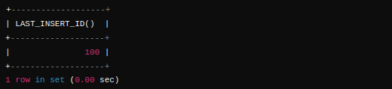

**3. Change the Cache value of the sequence EMPID_SEQ to 20 and maxvalue to 1000.**



**4. Insert values in the EMPLOYEES table using sequences for the Employee_id column.**



**5. Drop sequence EMPID_SEQ.**

